

**The economics of deflation**

Speech given by

Ben Broadbent, Deputy Governor for Monetary Policy, Bank of England

At Imperial College Business School, London 27 March 2015

I would like to thank Alina Barnett and David Learmonth for research assistance and I am grateful for helpful comments from other colleagues. The views expressed are my own and do not necessarily reflect those of the Bank of England or other members of the Monetary Policy Committee.

The CPI in February this year was no higher than in February 2014. This is the first time the UK has failed to record positive annual inflation for over 50 years. Inflation was briefly negative in late 1959 and early 1960. Before then, you have to go back to the early 1930s, and the agonies of the Great Depression, to find a period when UK consumer prices fell over a sustained period (Chart 1 plots three-year rolling averages of inflation). Because of the depth of the economic downturn at that time, and the more recent stagnation of Japan, the weakness of price inflation today has raised fears in some quarters about the risks of sustained deflation in this country.

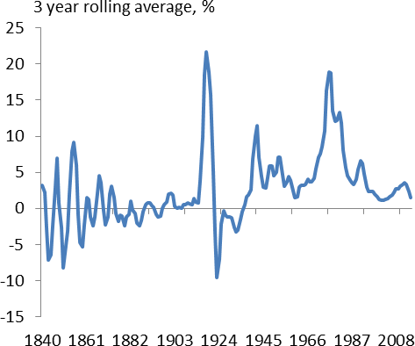The MPC’s objective is not simply to prevent prices from falling: it is to ensure they rise at the target rate of 2% a year. Because of the attention it’s been getting, however, I’m going to focus today on negative inflation specifically. I’ll divide the substance of my remarks in two. One part will discuss the basic economics – how and why it matters if prices decline over a protracted period – the other, the frequency and implications of deflation in the historical data.

|  |  |
| --- | --- |
| **Chart 1 Deflation last seen in 1930s** | Within that first section there are two points I’ll try and get across. One is the distinction between the price of what we buy (consumer prices) and the price of what we sell (mainly wages). For the moment it’s the first that’s fallen not the second: the drop in inflation has been driven largely by something that has significantly boosted real incomes (the sharp decline in commodity prices). It is what some have termed “good” deflation and, while it is unlikely to go on for that long, it is positive, not negative, for demand and output.  There is a risk that the fall in prices becomes more generalised and more sustained. If so – and this is the second point about the economics – what matters is not deflation per se but the capacity of  monetary policy to respond to it. |
| Source: ONS and Hills,Thomas, Dimsdale (2010). |

There are circumstances, in particular when the appropriate or “neutral” real interest rate is clearly positive, and when it’s not entirely unexpected, in which mild deflation wouldn’t pose a problem. I think Britain was in precisely that position for much of the classical gold standard period, during the second half of the

19th century (you can see from Chart 1 that periods of deflation were common at that time; as we shall see, they didn’t appear especially damaging for output growth). Deflation becomes a problem if, in conjunction with the zero lower bound on nominal interest rates, it prevents the monetary authority from setting a real short rate that’s sufficiently low to ensure stable growth.

Following the financial crisis, of course, the developed world has been in exactly that position: the neutral real rate of interest has been extremely depressed, official interest rates have been pushed to the zero lower bound and central banks have employed unconventional means of easing monetary policy. Were it to occur right now, sustained deflation would therefore pose more of a risk than at times when the neutral real rate was higher.

But, in my view, those risks are nonetheless relatively contained. For one thing I think the evidence suggests that unconventional policy is effective: even if they don’t circumvent it entirely, asset purchases help soften the constraint of the zero lower bound. Second, with the financial system gradually improving my guess is that the neutral real rate of interest is more likely to rise than fall over the next couple of years. Third, and most importantly, I think the chances of a sustained and widespread deflation are in any case low.

That’s certainly what the international experience suggests. That experience is substantial: we have annual CPI data since 1960 for over 70 countries, a total of over 3,000 data points. In only 70 cases (barely 2% of the sample) have consumer prices actually fallen and in the majority of those inflation was positive the following year. Of the 24 instances in which prices have fallen for more than one year, all but four – two in Japan, two in Bahrain – have occurred in developing countries with pegged exchange rates. In fact, there’s a general tendency for changes in inflation to be more persistent when the exchange rate is fixed. At least when policy has a degree of credibility, deviations of inflation tend to peter out relatively rapidly in countries with independent monetary policies.

In part this may reflect precisely the freedom to ease policy that, if it’s not ruled out by an exchange rate peg, may nonetheless be compromised by the zero lower bound. At least until it began to conduct QE, almost a decade after the economy began to turn down, Japan was clearly in this position. But I suspect it’s also because, when there’s an independent and credible policy, the risk that inflation expectations become

“de-anchored” from any target is lower to begin with.

As I say, for us that target is 2%, not zero. Even if the current undershoot is due mostly to the effect on the level of the CPI of the sharp drop in commodity prices, and should therefore have only passing effects on its rate of growth, our central expectation is that inflation will still be below target in a year’s time. All else equal, we probably need to see not just stable prices of commodities and other tradable goods if we’re to meet the target over a reasonable horizon, but some further acceleration in domestic costs as well. While that’s what

the central forecast in the February *Inflation Report* entails, the MPC will obviously have to be watchful, in the meantime, for signs that “good” deflation is turning into something worse.

But we should not over-state the risks.

# The costs of deflation: income and interest rates matter too

Something one hears quite often is that deflation is a problem “because it encourages people to postpone consumption”. Deflation – or more precisely the expectation that prices will fall – therefore weakens demand, it is said, and this can lead to a vicious circle in which prices are then depressed further.

As far as it goes this has some truth to it. But it’s at best a partial description of the problem, at worst a bit misleading. It leaves out two important considerations.

One is nominal income. Suppose you’re told that prices will fall over the next year but that the value of your income will remain unchanged. All else equal, the prospect of falling prices will give you an incentive to save more of your income (i.e. to postpone a bit of consumption). At the same time, the real value of that income will prospectively have risen. On most estimates of the various sensitivities the second effect will dominate the first and consumption should actually rise1, even before those price cuts actually arrive.

Conversely, if all prices fall simultaneously, including the price of labour (the nominal wage), then there’s no boost to real income to offset any increased tendency to save. Not only that, falls in nominal income would also expose the economy to a potentially much more serious risk, namely a rising burden of debt. Because the principal is fixed in nominal terms, shortfalls in cash income make debts harder to service, increasing the risk of financial instability and the pressure on debtors to cut back spending. It’s this “debt deflation” channel, emphasised originally by Irving Fisher and studied in depth by Ben Bernanke, amongst others, that is

thought to have been the main cost of falling prices and wages during the Great Depression. It’s therefore important to understand whether “deflation” is happening simply because there’s been a sharp drop in the price of something we buy – oil, say – or whether it’s a more generalised phenomenon in which nominal incomes too are falling.

The other important factor is interest rates. The incentive to save depends not on inflation expectations per se but on the (*ex ante*) real rate of interest. As long as nominal interest rates are higher than inflation – and that’s been the case through history, more often than not – foregoing £1 of spending today buys you more than £1’s worth of spending tomorrow. So this “postponement” effect doesn’t suddenly appear when

expected inflation dips below zero: it’s always there, to varying degrees, and depends on the extent to which expected inflation lies below the nominal rate of interest, i.e. the real interest rate.

Indeed, it’s partly by tweaking this incentive to save, via the short-term real rate, that monetary policy is in theory supposed to work. If confidence in the future suddenly declines, for example – something that would

1 Economists call the sensitivity of consumption to a change in its relative price over time the “inter-temporal elasticity”. That coefficient is poorly measured in the data but usually found to be relatively small and significantly less than one. At the same time, a permanent gain in real income should, even it’s expected to arrive only a year from now, prompt an immediate and almost one-for-one response of spending today. So, at least in principle, the positive “income effect” of a prospective drop in prices – holding fixed nominal pay – should be expected to outstrip the negative “inter-temporal substitution effect”.

on its own tend to push up rates of saving – the central bank will tend to react by lowering interest rates and pushing back in the opposite direction, in order to sustain demand. The appropriate real interest rate will therefore change over time. And the relevant question, in this context, is not so much whether people expect any sort of deflation, but whether they expect it at a pace that exceeds whatever is the appropriate real interest rate at the time2. If that were to happen, policy would run into the zero lower bound for nominal rates and central banks will find themselves reaching for unconventional policy tools.

Similarly, debt dynamics are driven not by nominal income growth in isolation but how that growth compares with nominal interest rates3. If the two fall rise and fall together – to the extent nominal interest rates can accommodate movements in nominal income growth – there’s no impact on debt accumulation: whatever proportion of income was needed to service debts beforehand is sufficient after the fact. It’s when income growth falls a lot further than the interest rate, and therefore when servicing debts requires much more of their incomes than people had expected, that problems can arise4.

# When (mild) deflation doesn’t matter: a high neutral real rate

I think you can see the importance of these considerations in the UK, both in recent history and, as it happens, over a much more distant period.

In the second half of the 19th century, and up until the First World War, Britain and much of the advanced world were on the Gold Standard: the price of gold was fixed at £3.83/oz. Deflation was commonplace. Discoveries of gold occurred only intermittently, and because the global economy – and therefore the demand for currency – was generally expanding, its real price often came under upward pressure. With the nominal price fixed, the only way that could happen is if the denominator of that real price – the price of goods and services – declined. Thus UK consumer prices fell significantly during the 1840s, for example, and again in the late 1850s; they also fell through the 1880s (Chart 2). And although real pay tended to grow over time, these deflations were sometimes severe enough to mean that nominal wages declined.

2 If the appropriate real rate is r* then the central bank would ideally want to set a nominal rate of r*+ πe, where the second term is inflation expectations. But nominal rates can’t be lower than zero – or whatever number, close to zero, constitutes the effective lower bound – so if r*+ πe < 0 the actual real rate will be higher than it should be. Note that this can happen either if πe is well below zero or if, as has been the case since the crisis, the same happens to r*.

3 If b is the ratio of debt to income then its growth rate is given by r − g − s/b, where r is the ex post interest rate, g the growth rate of income and s the proportion of income used to pay off debt. So if g falls and r does not either debt starts rising faster than income or

debtors must save more; if r and g change by the same magnitude b and s don’t have to.

4 The lower bound for nominal interest rates may be relevant in this context too: in the United States wage growth averaged -13% between 1929 and 1932 and, by the time that deflation got going, it would have been impossible to cut interest rates to those sorts of levels. This led to dramatic rises in the burden of debt and rates of default.

|  |  |
| --- | --- |
| **Chart 2 Deflations common during Gold Standard** | However, there’s no evidence this had an especially severe effect on the economy. To be sure, lower inflation was associated with weaker GDP growth, lower wage growth with higher unemployment  (Charts 3 and 4). But there doesn’t look to be anything particularly bad about negative inflation: as far as one can tell, the economic cost of moving from of zero to  -1% (say), whether in price or wage space, wasn’t any worse than that involved in going from 5% to 4% (for example5).  One reason for this may be that people were adapted to the regime – they were used to the idea that prices, and even nominal wages, occasionally declined, and because these things were therefore more flexible, it didn’t take an especially severe recession to get that  to happen. |
| Source: ONS and Hills,Thomas, Dimsdale (2010). |

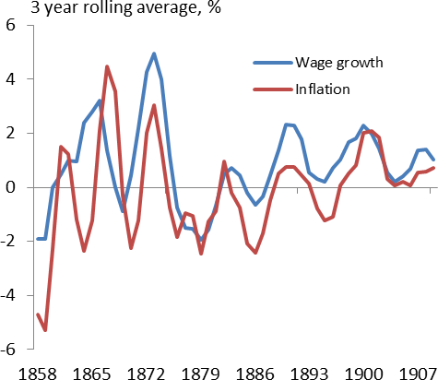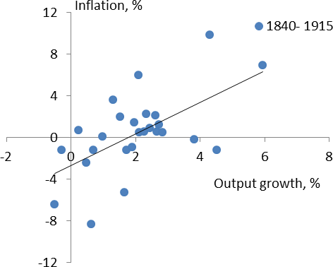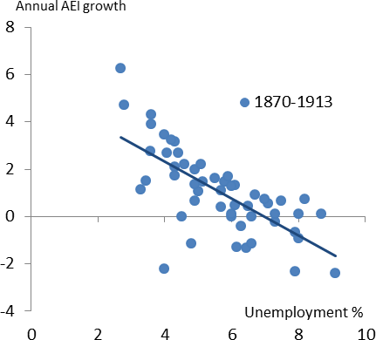

|  |  |
| --- | --- |
| **Chart 3 Those deflations no more costly than other disinflations…** | **Chart 4 …same was true for wage growth** |
| Source: ONS and Hills,Thomas, Dimsdale (2010). | Source: ONS and Hills,Thomas, Dimsdale (2010). |

5 If deflations per se were costly you’d expect to see Charts 3 and 4 become shallower south of the origin.

|  |  |
| --- | --- |
| **Chart 5 Interest rate unconstrained by zero bound** | But what must also have been important, it seems to me, is that the appropriate level of real interest rates was sufficiently high through the period that monetary policy never had to contend with the zero lower bound on the nominal rate6. Chart 5 adds to Chart 2 the series for Bank Rate, in green. The real short-term interest rate – which we know, after the event, can’t have deviated that much from the level necessary to sustain stable growth and prices (since that’s what generally occurred) – averaged 4% between 1850 and 1914. If the neutral real rate is anything like that high, only a very severe deflation would drag the appropriate nominal rate close to zero. As it was, Bank Rate was unconstrained from responding to lower nominal  growth7, when that occurred, and never fell below 2%. |
| Source: ONS and Hills,Thomas, Dimsdale (2010). |  |

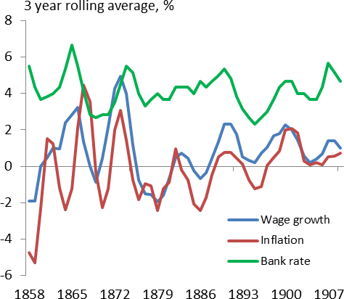Perhaps the authorities of the time were just lucky not to have run into the zero lower bound. But I think this episode illustrates that even protracted declines in prices needn’t be especially costly if, for whatever reason, the appropriate real interest rate is relatively high.

# Sustained deflation more costly when interest rates close to the lower bound

Clearly, we are not in the same position today. Cuts in interest rates after the financial crisis were crucial in preventing a much worse downturn. They depressed the real short rate, softening what might otherwise have been a steeper rise in the saving rate. Matching the decline in productivity and income growth (Chart 6), the resulting falls in household interest rates meant deleveraging could occur without a big jump in gross debt repayments8. Net of interest payments, growth of nominal incomes has been little different over the past six years than it was in the pre-crisis decade (Chart 7).

But balance sheets and gross debts are clearly far larger now than in the late 19th century. Productivity and real income growth have been significantly lower and, partly for that reason, the neutral real interest rate fell steeply after the crisis and almost certainly into appreciably negative territory. So even without deflation,

6 By “zero” I mean the *effective* lower bound on nominal interest rates; this may not be precisely zero.

7 I say “respond” but, as a broad generalisation, the Gold Standard allowed for no significant degree of monetary autonomy: there might be a number of explanations for the pro-cyclicality of real short-term interest rates but they were not, by and large, a matter of free

choice of the central bank (Obstfeld et al (2005); for a recent and interesting discussion, see also Morys (2012)). My point is that, had there been a lower neutral real rate, the Gold Standard would have delivered a worse outcome in co-ordinated downturns because the lower bound may have been a constraint.

8 Recall that the evolution of debt:income ratios depends on the gap between interest rates and income growth (footnote 3), i.e. the two lines in Chart 6. The fact this gap failed to widen didn’t prevent a significant impact of the credit crunch on spending: that’s effectively

because, during such episodes, the maximum allowable debt:income ratio declines. So spending is forced to contract even without any increase in (r-g).

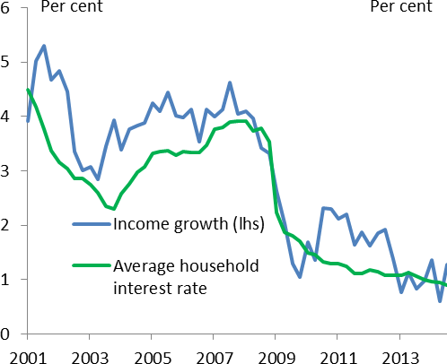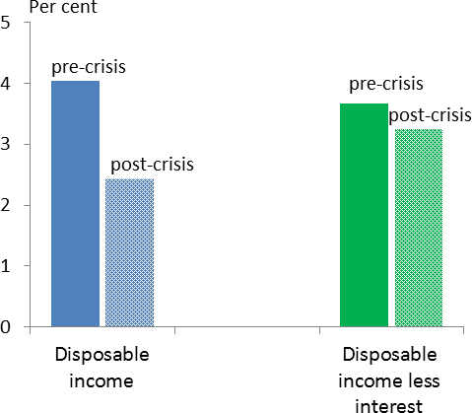central banks have found themselves up against the zero lower bound and compelled to employ unconventional policy tools. As a result, there is now less room to deal with any entrenched and protracted deflation, in prices and wages alike, should that occur.

|  |  |
| --- | --- |
| **Chart 6 Spread between nominal interest rates, income growth broadly stable** | **Chart 7 Net of interest payments, nominal income growth little changed since crisis** |
| Source: ONS. | Source: ONS. |

# A good disinflation so far…

What are the chances of such a thing? Certainly what we’ve had in the past few months doesn’t qualify. In fact, it’s been a largely positive story, because the fall in inflation has been driven not by the declining value of what we sell, including wages – though weak by pre-crisis standards, nominal income growth has actually risen slightly of late – but by a steep fall in the real price of something we buy9. This therefore counts as what the economist Michael Bordo calls a “good” disinflation, driven by an improvement in productivity or (as in this case) the terms of trade. In the year to 2014Q4 real per capita disposable income grew at its fastest rate for seven years; real income growth is likely to have picked up further in 2015Q1 (Chart 8).

There is evidence this has already fed through to spending and to household confidence. Real household consumption too rose at its fastest pace for seven years during the course of 2014. And this occurred despite a marked decline in survey measures of households’ near-term inflation expectations (Chart 9) – little evidence here that weaker inflation expectations delay or depress consumer spending.

9 This point was made in a recent speech by the Governor (Carney (2015)) and, in an article, by Kristin Forbes (2015).

|  |  |
| --- | --- |
| **Chart 8 Drop in commodity prices has boosted real per capita income** | **Chart 9 Financial market measures of inflation expectations close to average** |
| Source: ONS; ex income from and consumption of imputed rents. | Source: Source: Bank of England, Barclays Capital |

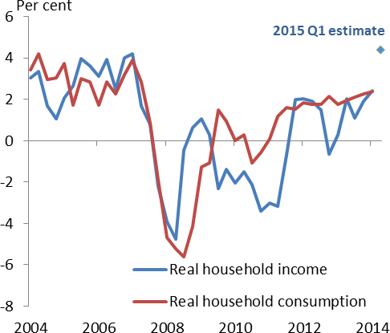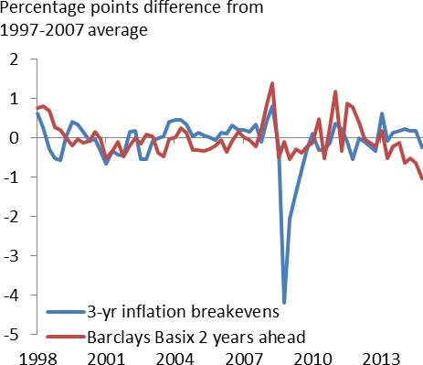In truth, I don’t think we should be terribly surprised by this. Theory says households will raise consumption one-for-one with any increase in the level of real income deemed to be permanent. In practice people may

take time to react to real income shocks; it’s also possible they expect some of the recent declines in energy prices to be reversed10. But, in the data, there’s no correlation between household saving rates and changes in real energy prices, either here or elsewhere in the OECD11. This suggests their effects on income are in general matched by equivalent shifts in real spending. Note that the UK is not the only place where consumer confidence has risen in recent months (Chart 10).

Nor is it unusual to see stronger demand at a time when these survey measures of household inflation expectations are falling. Typically, these near-term expectations surveys track actual inflation12. And quite a bit of the high-frequency variation in the CPI arises from things that don’t directly affect nominal pay – taxes and import prices, for example – but do affect its real value. When taxes or import prices go down, real incomes rise (and vice-versa). This produces a negative near-term correlation between inflation and real income growth; controlling for nominal pay, there is also a clear negative correlation between surveyed inflation expectations and household optimism (Chart 11).

10 Forward markets discount an oil price of $69/bl at the end of next year, quite a bit higher than the current spot price though still well below where it was in mid-2014 ($54 and $110 respectively).

11 In regressions of changes in saving rates on the contribution to real income growth of energy and food prices, the estimated coefficient is close to zero and statistically insignificant in all 17 OECD countries for which we have data.

12 By contrast, they contain no significant information about future inflation beyond past inflation itself. In other words, in regressions of inflation on lags of itself and lagged expectations, the estimated coefficients on the latter are typically statistically insignificant.

|  |  |
| --- | --- |
| **Chart 10 Consumer confidence has strengthened in US, Euro area** | **Chart 11 Surveyed household inflation expectations, optimism negatively correlated** |
| Source: European Commission, Conference Board | Source: ONS, Gfk/EC, Barclays Capital.  Note: * after controlling for current wage growth. |

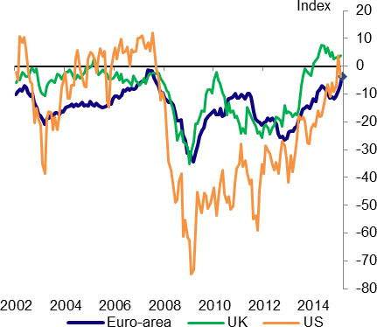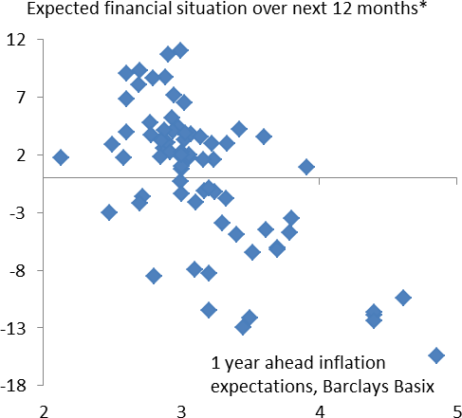These results might give one pause about whether the “delayed consumption” channel really is that important, or whether the surveys of inflation expectations are really telling you about what matters. The link between consumption and real interest rates is not an empirically strong one13. Other measures of inflation expectations – for example from financial markets – are less depressed (Chart 9). A recent study using US data found that, even controlling for nominal income, there was no correlation across individuals between their reported expectations of inflation and spending14. At the very least, the results are a reminder not to consider current inflation or survey measures of household inflation expectations on their own, but in the context of what’s happening to incomes and interest rates.

# International experience: proper deflations are rare, especially in countries with floating currencies

That doesn’t mean we can rest entirely easy. In particular, it would be wrong blithely to assume that positive nominal income growth will continue, come what may. Deflations have to start somewhere and there is a risk that falling prices will beget yet weaker or even negative wage growth – that today’s “good” deflation will metastasise into something a good deal worse. Bordo classifies “bad” disinflations as those that coincide

with recessions, “ugly” episodes as steep and generalised falls in nominal quantities, all the uglier in the presence of large gross debts.

However, my own view is that the chances of such an outcome are relatively low. I say that partly because base effects will naturally give a big positive impetus to annual inflation in early 2016. “Core” inflation is still

13 David Miles made this point in a recent speech (Miles (2015)). To take a few of many studies, see also Hansen and Singleton (1982), Campbell and Mankiw (1989) and Canzoneri et al (2005).

14 Bachmann et al (2015).

running at over 1% and, barring another steep decline in food and energy prices over the next year, headline inflation is likely to rise quite steeply in early 2016.

I’m also struck by the rarity of persistent deflation in the past15, particularly amongst countries with an independent monetary policy. As we’ve seen, long periods of falling prices were perfectly common during the Gold Standard. That’s inevitable under a commodity peg if, over any period of time, the commodity itself is in fixed supply. The same was true in other countries at the time and, infamously, during the Great Depression. It was only when Britain came off gold, in 1931, that its nominal income started to accelerate16.

And since the Second World War, and the abandonment of commodity standards, positive inflation has been the norm – so much so, in fact, that the commonly cited example of the Japanese deflation is almost unique.

|  |  |
| --- | --- |
| **Chart 12a Deflation episodes are rare** | **Chart 12b Even rarer in countries with floating exchange rates** |
| Source: Bordo and Eichengreen, IMF and OECD Note: Sample 1960-2010; 3300 observations | Source: Bordo and Eichengreen, IMF and OECD Note: Sample 1960-2010; 3300 observations. |

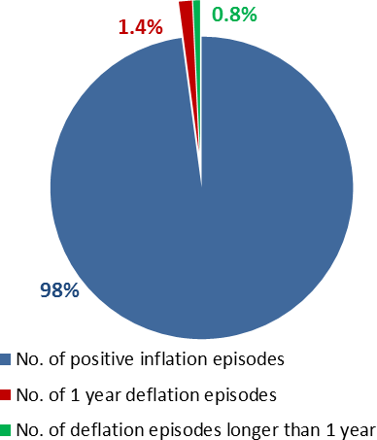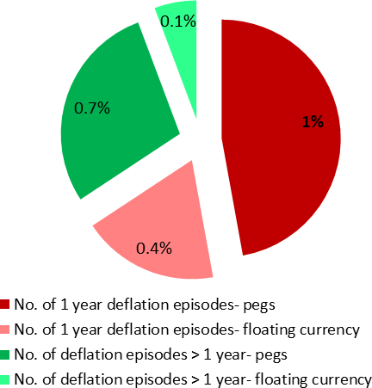The international data on consumer prices are relatively rich: we have annual numbers for over 70 countries, most of them back to 196017. In all, across countries and years, there are 3,300 separate post-war observations. In only 70 of these – barely 2% of the sample – has inflation actually been negative

(Chart 12a); the majority of these “deflations” (46 out of 70) have lasted no more than a year, many of these shorter episodes coinciding with falls in oil prices; of the 24 deflations lasting two or more years, 20 have been in economies with fixed exchange rates, most of those emerging economies; among countries with

15 A very recent paper by Claudio Borio and co-authors at the BIS makes the same point (Borio et al. (2015)); see also Broadbent et al (2010).

16 For more on the contractionary effect of the Gold Standard during the Great Depression, see Eichengreen (1996).

17 Data from Bordo and Eichengreen (1999), updated from OECD and IMF sources.

freely floating exchange rates, only Bahrain and – somewhat more famously – Japan have experienced protracted deflations, both of them twice (Chart 12b). This is not a common occurrence.

# A credible monetary policy reduces the persistence of movements in inflation

Why might deflations be rarer in countries with floating exchange rates, and in emerging economies, and should this provide any reassurance today? Yes, I think – to a degree.

One plausible reason for this pattern is that countries with fixed exchange rates give up autonomy to control their own rate of inflation. Instead, domestic inflation is determined by (i) inflation in the country to which their exchange rate has been fixed (most often the US) and (ii) forces affecting their real exchange rate. Those forces are often important in emerging markets: their terms of trade move around more and they are also subject to more volatile financial flows than developed countries. Shocks that would tend to depress the nominal exchange rate, were it free to fall – a drop in the terms of trade, for example, or heightened risk aversion and capital flight – instead show up as negative inflation18.

It’s not just the volatility that’s higher, however: it turns out that shocks to inflation are also more persistent in countries with fixed exchange rates (Chart 13; see also Monacelli and Gali (2005)). And while this may simply reflect the particular disturbances affecting the equilibrium real exchange rate – perhaps they play out only over time – it’s also possible that the persistence of inflation owes something to the lack of a stable domestic objective for monetary policy.

In our theories, wage and price-setting are forward looking: high (low) expectations of inflation over the future drag up (depress) actual inflation today. That’s precisely why central banks concern themselves with the

stability of inflation expectations. It’s also why a credible inflation target is to some degree self-regulating. If people expect inflation generally to be on target, over the medium term, the central bank has to do less actively to ensure it. Notably, the persistence of movements in UK inflation fell sharply after the introduction of inflation targeting in 1992 (Chart 14). To the extent this reflects improved credibility it implies less of a need for policy to respond to one-off hits to the price level.

18 The capacity of fixed-exchange rate systems to experience genuinely inflationary shocks – those that move wage and price inflation jointly – is also evident in Chart 2. The correlation between wage and price inflation was +0.6 during the classical Gold Standard; under inflation targeting it’s been -0.2. That may also reflect a more volatile environment for real wages shocks (i.e. to the terms of trade and productivity). Nor are floating exchange rates a guarantee of stable inflation: during the 1970s and 1980s, when there was no stable nominal target at all, this correlation rose to 0.9. But inflationary shocks appear better contained with a domestic inflation target than an exchange rate or commodity peg.

# Chart 13 Inflation more persistent under fixed exchange rates

**Chart 14 UK inflation persistence fell after introduction of inflation targeting**

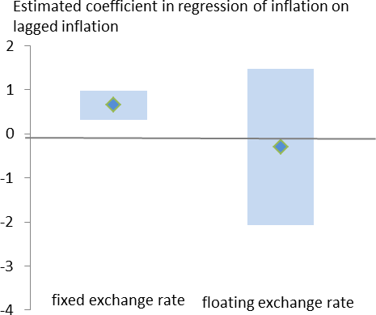1.6

1.2

0.8

0.4

0.0

Estimated coefficient in regression of UK inflation on lagged inflation, 20 year rolling window

Consumption deflator GDP deflator

1962 1972 1982 1992 2002 2012

Source: Bordo and Eichengreen (1999), IMF and OECD.

Note: Blue shaded area represents +/- 2SD around diamond central estimate of a panel regression; sample 1960-2010.

Source: ONS and Hills, Thomas, Dimsdale (2010).

# Conclusion: policy should be flexible but don’t over-react to low inflation

We’ve heard a lot about the risk that deflationary expectations persuade people to defer spending. We’ll no doubt hear it again if inflation were to dip below zero over the next couple of months. But it’s at best a partial point. All else equal, the incentive to save depends not on inflation expectations *per se* but on how far away they are from the nominal interest rate, i.e. the real interest rate. By any measure – even if you use the

near-term household surveys as measure of inflation expectations – the real rate is extremely low, and still negative (Chart 15). The extensive empirical evidence for this “inter-temporal substitution” channel is in any case relatively weak – as the Governor pointed out recently, the more important threat, particularly in developed economies with large balance sheets, is debt deflation. And in that regard, it’s the gap between interest rates and nominal income growth that matters. Notably, nominal income growth has not declined of late.

Real interest rates still need to be low. Our inflation target is 2% not zero: what makes the current position “good” is not low inflation *per se* but the fact that, in this particular instance, it’s been caused by something (a drop in oil prices) that improves real incomes. Even though the direct effect of that decline will drop out of the annual comparison later this year and in early 2016, there’s a risk that, by depressing wage growth,

sub-target inflation could persist for longer than we expect.

|  |  |
| --- | --- |
| **Chart 15 Real interest rates are low** | More fundamentally, as I sought to explain in a recent speech, the “neutral” interest rate consistent with stable growth and inflation seems to have fallen significantly over the years, both before and since the financial crisis. That’s why, even without deflationary expectations, central banks came up against  the zero lower bound for interest rates. And it’s that zero bound that ultimately makes deflations costly. |
| Source: BOE, Barclays Capital and own calculations. |  |

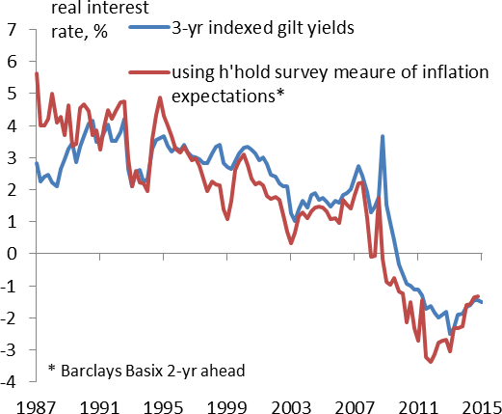My own view, however, is that the likelihood of a broad and protracted deflation, afflicting wages as well as prices, is pretty low. The evidence suggests that asset purchases positively affect nominal growth – they may not by-pass the lower bound on interest rates but they certainly soften it. My guess is that, with the financial system improving, and signs that the worst fears about the global economy may be subsiding, the neutral real interest rate is more likely to rise than fall over the next couple of years. Over that period, headline inflation will get a sizeable kick upwards, once the falls in food and energy prices drop out of the annual comparison. In the meantime, the UK labour market continues to tighten – low inflation won’t be the only influence on pay growth this year – and the boost imparted by lower commodity prices to real incomes is already apparent in higher consumer spending, here and in other countries too.

Finally, history tells us these episodes are rare – rare, in the case of developed countries with floating exchange rates, almost to the point of uniqueness.

Thank you.

**References**

**Bachmann R, Berg T and E Sims,** 2015, “Inflation expectations and readiness to spend: cross- sectional evidence”, *American Economic Journal*, 7(1), pp. 1-35.

**Bordo, M, Filardo A, Velasco, A and C Favero**, 2005, “Deflation and monetary policy in a historical perspective: remembering the past or being condemned to repeat it?”, Economic Policy, Vol. 20, No. 44, pp. 801-844.

**Borio, C, Erdem M, Filardo, A and Hofmann B**, 2015, “The costs of deflations: a historical perspective” *BIS Quarterly Review*, March.

**Broadbent B, Daly K and S Carlson**, 2010, “Global economics weekly”, Goldman Sachs Global Economics, No. 10/32

**Campbell J Y and N G Mankiw**, 1989, “Consumption, income and interest rates: reinterpreting the time series evidence” *NBER Macroeconomics Annual* 1989, Volume 4, MIT Press.

**Canzoneri M, Cumby R and B Diba**, 2005, “Euler equations and money market interest rates: A challenge for monetary policy models”, *Journal of Monetary Economics*, No 54, pp. 1863–1881.

**Carney, M**, 2015, “Writing the path back to target”, Speech at the Advanced Manufacturing Research Centre, Sheffield, and available at <http://www.bankofengland.co.uk/publications/Documents/speeches/2015/speech808.pdf>

**Forbes, K**, 2015, op-ed in Evening Standard, [http://www.standard.co.uk/business/markets/kristin-forbes-](http://www.standard.co.uk/business/markets/kristin-forbes-zero-inflation-is-here--but-theres-no-need-for-soulsearching-10133157.html) [zero-inflation-is-here--but-theres-no-need-for-soulsearching-10133157.html](http://www.standard.co.uk/business/markets/kristin-forbes-zero-inflation-is-here--but-theres-no-need-for-soulsearching-10133157.html)

**Gali, J and T Monacelli**, 2005, Monetary Policy and Exchange Rate Volatility in a Small Open Economy,

*The Review of Economic Studies*, Vol. 72, No. 3 (Jul., 2005), pp. 707-734.

**Hansen, L and K Singleton**, 1982, Generalized instrumental variables estimation of nonlinear rational expectations models, *Econometrica*, Vol. 50, No. 5, pp. 1269-1286.

**Hills S., R. Thomas and N. Dimsdale**, 2010, “The UK recession in context - what do three centuries of data tell us?”, *Bank of England Quarterly Bulletin*, 2010 Q4.

**Eichengreen B,** 1996, “Golden Fetters. The Gold Standard and the Great Depression, 1919-1939”, NBER Series on Long Term Factors in Economics Development, *Oxford University Press*

**Miles D**, 2015, “What can monetary policy do?” Speech given at University of Edinburgh Business School, Edinburgh and available at [www.bankofengland.co.uk/publications/Documents/speeches/2015/speech791.pdf.](http://www.bankofengland.co.uk/publications/Documents/speeches/2015/speech791.pdf)